Boosting on a
p-convex hull

Fourth year project seminar
Wednesday, July 28, 1999
Jeremy Barnes

Contents
- The classification problem
- A simple learning algorithm
- Boosting
- “p-boosting”
- Progress to date
- Further work

The classification problem

Machine learning framework
- Given a number of samples
- Constant (but unknown) probability distribution over input space
- Want to infer a general relationship

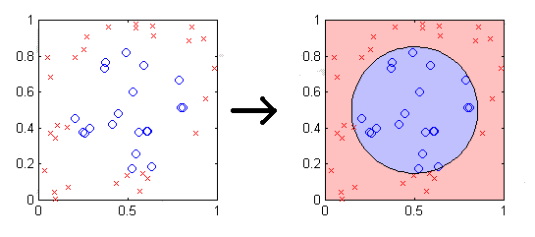

Statistical learning theory
- Everything has a probability density function
- We aim to match that PDF
- Zero errors usually not possible
A hard problem
Problems:
- Noise
- Attribute noise
- Classification noise

- Sparse data
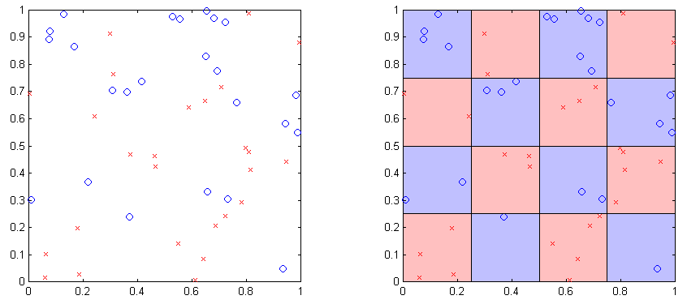
- Difficult in high number of dimensions
- A priori knowledge very important

Overfitting
- If we have a “rich” enough class of functions, we can fit any data.

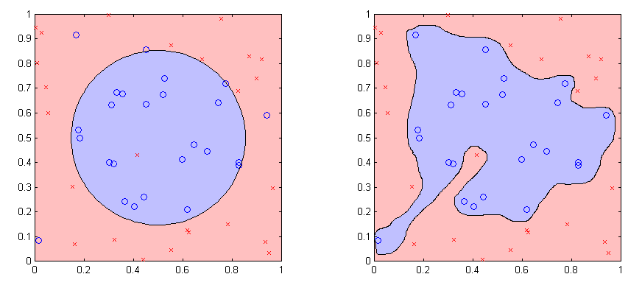
- Also fitting the noise ➔ not matching the PDF
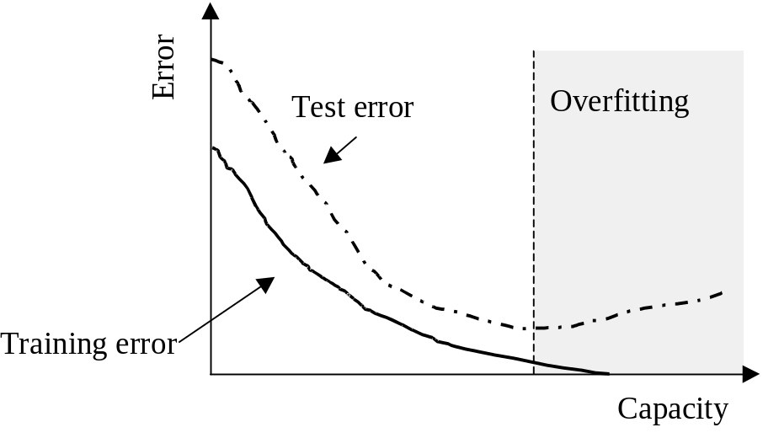
- We need capacity control to get best performance
A simple learning algorithm

Decision stumps

- Decision ➔ makes a “decision” based on one variable
- Stump ➔ smallest possible “decision tree”
- Splits orthogonal to one axis

Training
- Decision boundary orthogonal to one axis
- Choose the {variable, split point} combination that minimises training error
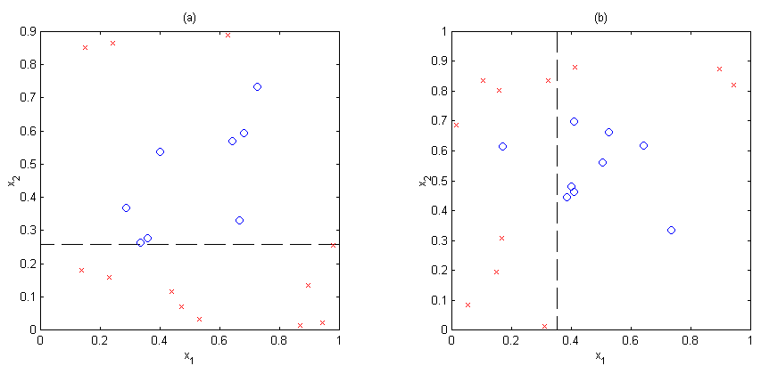
“Margin surface” view
- sign(margin) ➔ class
- |margin| ➔ confidence

Margin surface of a decision stump classifier + 1
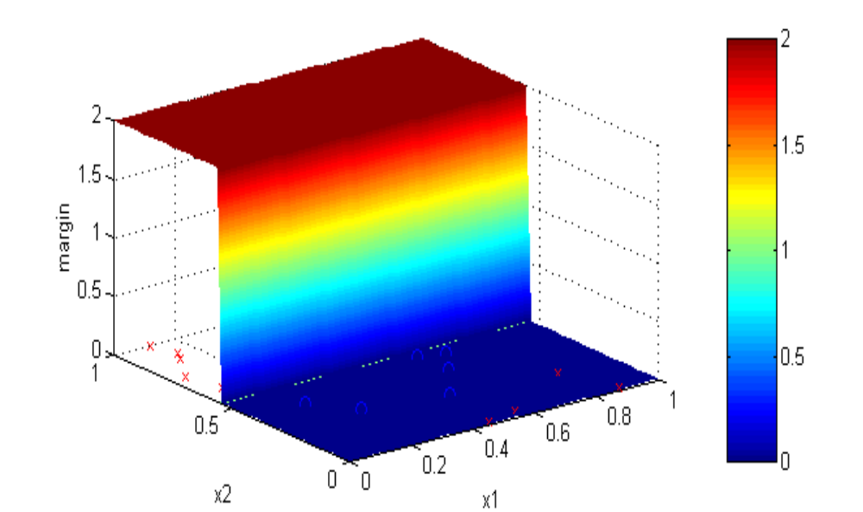
- Low = o, high = x
- Easy visualisation of the shape of a learning algorithm
Boosting (Freund & Schapire)

Combines many “weak” classifiers f into one “strong” classifier F that works very well

Key features
- Weak classifier 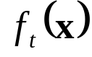 added at time 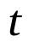
- Linear combination
- Classifier weights b depend upon training error of weak classifier
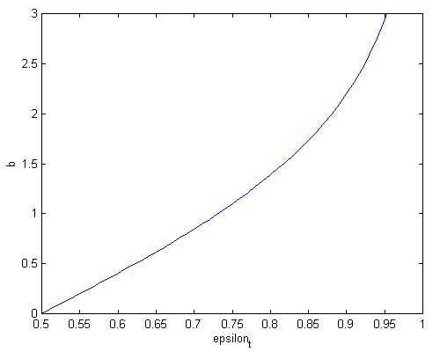
- Convex hull: 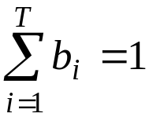
- Sample weights force algorithm to concentrate on hard samples
Boosting as gradient descent
- Recent work: boosting uses gradient descent to obtain optimal classifier
- Choose a cost function C(F) (usually increasing with training error)
- Define a surface:
- Height is given by C
- Domain is all linear combinations
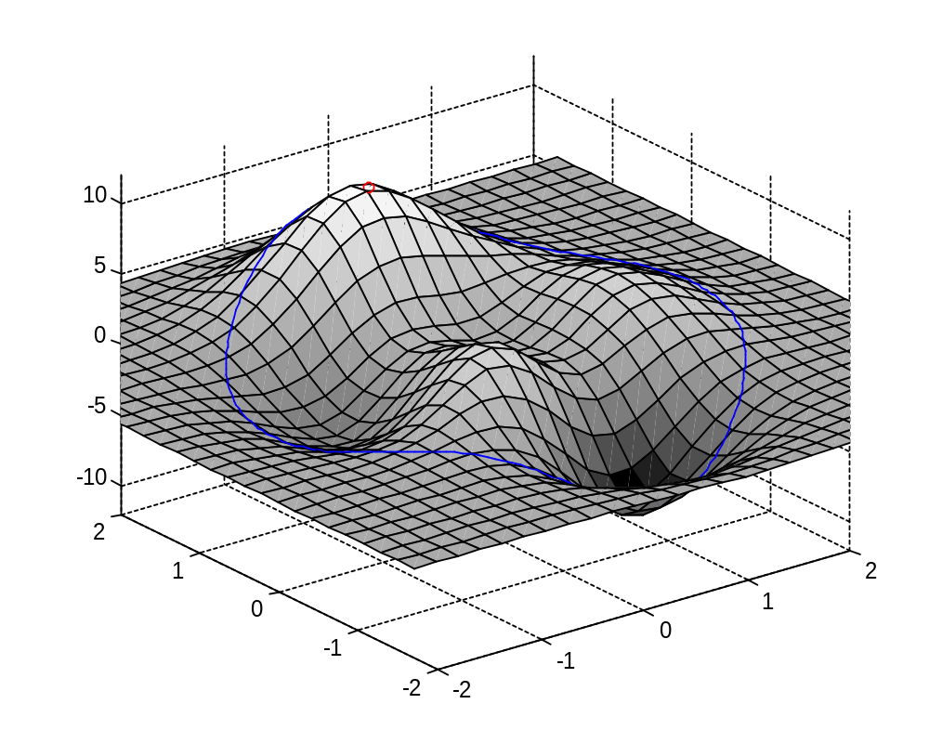
- Domain is within blue circle
- Descending from red point
Gradient descent 2
Gradient descent does the following:
- Find “direction” f_{t} that points in the direction of maximum steepness
- Choose the step size b_{t} to take in this direction (line search)
- Repeat until there is no downwards direction
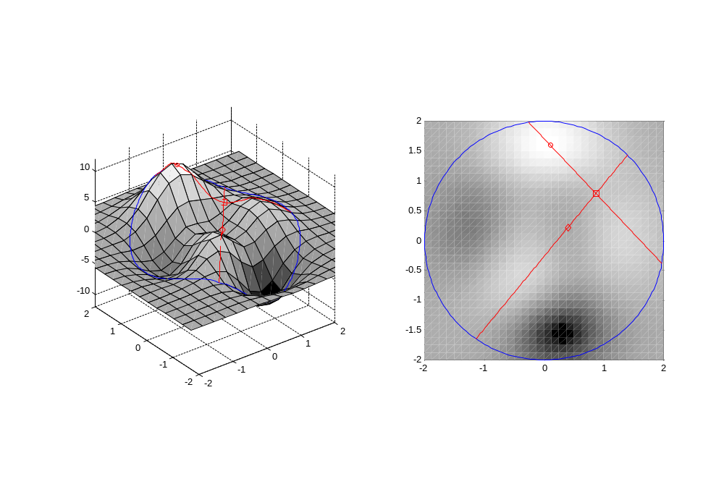
- “Direction” is changed by modifying the sample weights
- “Step size” is given by classifier weights
Modifying gradient descent
Four degrees of freedom:
- Which linear combinations will we allow? (boosting: convex hull)
- How will we measure gradient? (boosting: inner product at sample points)
- What is our cost function? (boosting: exponential approximation to training misclassification risk)
- How do we choose a step size? (boosting: line search)
My project modifies 1 and 3.

Performance of boosting
- Boosting works very well
(but)
- Boosting overfits on noisy data

(decision surface on noisy data)

(training error vs iterations for noisy data showing overfitting)
- Improvement if we can implement capacity control on combined hypothesis F.
p-boosting

- My project uses “p-boosting” to implement capacity control
- By “p-boosting”, I mean using a p-convex hull 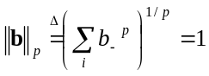 instead of a normal (p=1) hull.

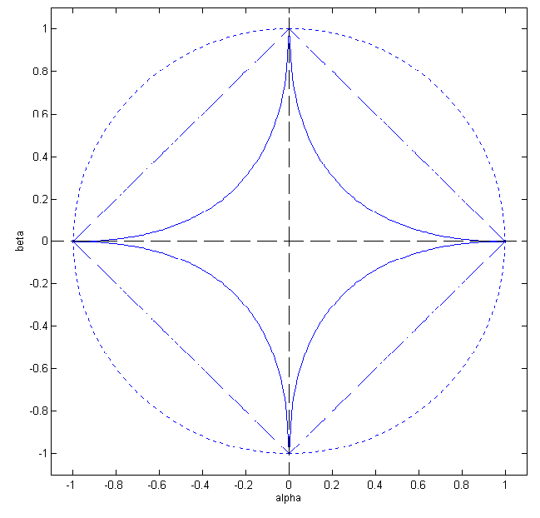
p=2
p=1
p=1/2

(Plot is of 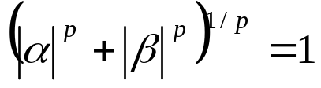)
- p < 1 ➔ Smaller class of functions ➔ capacity control
What I have done
- Background reading
- Framework
Computer code
- MATLAB library
- Decision stumps, CART, boosting
- Hand-optimised: 20 hours for 1,000,000 iterations
Theory
- Modification to boosting ➔ performs poorly
- Gradient descent explains why
How to implement p-boosting?
Method 1: domain restriction
- Use only combinations that lie within a p-convex hull
- Which linear combinations?
(p-convex hull)
- How will we measure gradient?
- Cost function?
- Step size?

Method 2: regularisation
- Which linear combinations?
(large set, eg. ball)
- How will we measure gradient?
- Cost function?
(large p-norm penalised)
- Step size?
Method 1: Domain restriction
- Choose combinations on a p-convex hull
- For p < 1, this leads to a smaller class of functions
Problems
- May have trouble getting out of “corners”
- We no longer have convexity

Method 2: Regularisation

- Choose cost function of the form 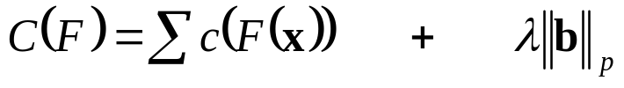
- First term: low misclassification risk (as usual)
- Second term: low p norm
- λ chooses a balance between these two goals
Advantages
- Flexibility to choose our universal set ➔ avoid “corners”
Problems
- Now have two parameters: λ and p
- How does this affect the decision “landscape”: local minima?

Further work

- Work through gradient descent to find algorithms for these two methods
- Test these methods
- Noisy data
- 100 repetitions of each test
- 10000 iterations of boosting

Questions to answer
- There should be an optimal value of p. Is there?
- Effect of p on training time.
- Is there merit in p > 1?

Your questions

